**EXPERIMENT NO:-10**

***Aim: prepare RMMM plan for the project.***

**Theory:**

The goal of the risk mitigation, monitoring and management plan is to identify as many potential risks as possible. When all risks have been identified, they will then be evaluated to determine their probability of occurrence, and how project will be affected if they do occur. Plans will then be made to avoid each risk, to track each risk to determine if it is more or less likely to occur, and to plan for those risks should they occur.

It is the organization’s responsibility to perform risk mitigation, monitoring, and management in order to produce a quality product. The quicker the risks can be identified and avoided, the smaller the chances of having to face that particular risk’s consequence. The fewer consequences suffered as a result of good RMMM plan, the better the product and the smoother the development process.

Risks can be categorized as follows.

1. Project Risk
2. Technical Risk
3. Business Risk

Another categorization can be.

1. Known Risk
2. Predictable Risk
3. Unpredictable Risk

There are two distinct types of risks for each of the above categories that have been presented that is generic risks and product-specific risks. *Generic risks* are a potential threat to every software project. *Product- specific risks* can be identified only by those with a clear understanding of the technology, the people, and the environment that is specific to the project at hand

RISK IDENTIFICATION

One method for identifying risks is to create a *risk item checklist which* focuses on some subset of known and predictable risks in the following generic subcategories:

* *Product size*—risks associated with the overall size of the software to be built or modified.
* *Business impact*—risks associated with constraints imposed by management or the market place.
* *Customer characteristics*—risks associated with the sophistication of the customer and the developer’s ability to communicate with the customer in a timely manner.
* *Process definition*—risks associated with the degree to which the software process has been defined and is followed by the development organization.
* *Development environment*—risks associated with the availability and quality of the tools to be used to build the product.
* *Technology to be built*—risks associated with the complexity of the system to be built and the "newness" of the technology that is packaged by the system.
* *Staff size and experience*—risks associated with the overall technical and project experience of the software engineers who will do the work.

# Developing a Risk Table

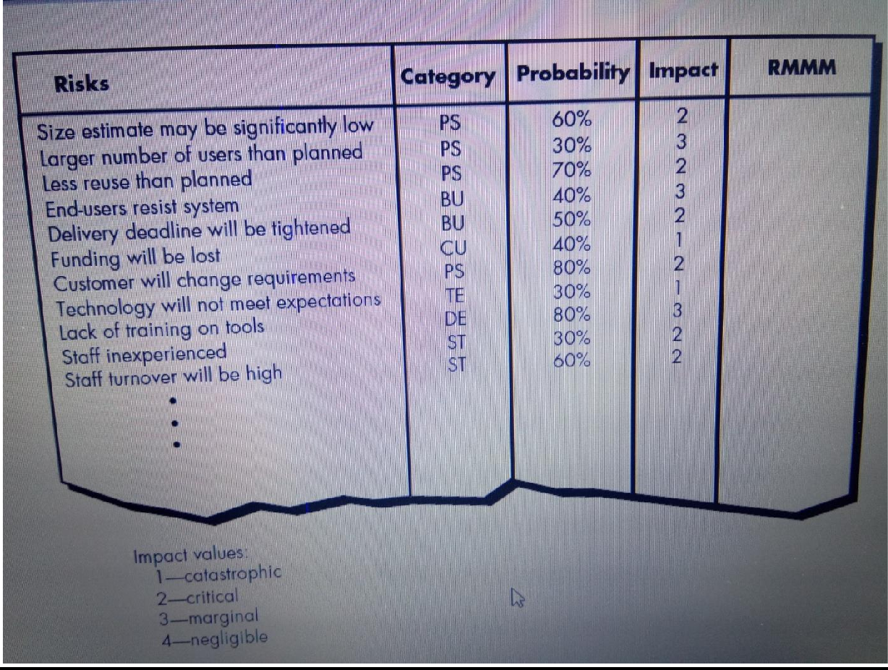

**RMMM Plan**

The RMMM plan documents all work performed as part of risk analysis and is used by the project manager as part of the overall project plan. Some software teams do not develop a formal RMMM document. Rather, each risk is documented individually using a *risk information sheet* (RIS)

Example.

# Risk: Customer will change Requirements

Category: PS Probablity: 80% Impact:2

# Mitigation

In order to prevent this from happening, the software will be developed with the end user in mind. The user-interface will be designed in a way to make use of the program convenient and pleasurable.

# Monitoring

The software will be developed with the end user in mind. The development team will ask the opinion of various outside sources throughout the development phases. Specifically the user-interface developer will be sure to get a thorough opinion from others.

# Management

Always trying fulfill the all the requirements from the customer at any cost. From our side we give extra facilities also.Should the program be resisted by the end user, the program will be thoroughly examined to find the reasons that this is so. Specifically the user interface will be investigated and if necessary, revamped into a solution.

# Risk: Technology Does Not Meet Specifications

Category: TE Probablity: 30% Impact:1

# Mitigation

In order to prevent this from happening, meetings (formal and informal) will be held with the customer on a routine business. This insures that the product we arE producing, and the specifications of the customer are equivalent.

# Monitoring

The meetings with the customer should ensure that the customer and our organization understand each other and the requirements for the product.

# Management

Should the development team come to the realization that their idea of the product specifications differs from those of the customer, the customer should be immediately notified and whatever steps necessary to rectify this problem should be done. Preferably a meeting should be held between the development team and the customer to discuss at length this issue.